Data Structure and Algorithm

Laboratory Activity No. 6

Singly Linked Lists

|  |  |
| --- | --- |
| *Submitted by:* | *Instructor:* |
| Polestico,Paul Justine D. | Engr. Maria Rizette H. Sayo |

August, 23, 2025

# Objectives

Introduction

A linked list is an organization of a list where each item in the list is in a separate node. Linked lists look like the links in a chain. Each link is attached to the next link by a reference that points to the next link in the chain. When working with a linked list, each link in the chain is called a Node. Each node consists of two pieces of information, an item, which is the data associated with the node, and a link to the next node in the linked list, often called next.

This laboratory activity aims to implement the principles and techniques in:

* Writing algorithms using Linked list
* Writing a python program that will perform the common operations in a singly linked list

# Methods

* Write a Python program to create a singly linked list of prime numbers less than 20. By iterating through the list, display all the prime numbers, the head, and the tail of the list. (using Google Colab)
* Save your source codes to GitHub

# Results

Present the visualized procedures done. Also present the results with corresponding data visualizations such as graphs, charts, tables, or image . Please provide insights, commentaries, or explanations regarding the data. If an explanation requires the support of literature such as academic journals, books, magazines, reports, or web articles please cite and reference them using the IEEE format.

Please take note of the styles on the style ribbon as these would serve as the style format of this laboratory report. The body style is Times New Roman size 12, line spacing: 1.5. Body text should be in Justified alignment, while captions should be center-aligned. Images should be readable and include captions. Please refer to the sample below:

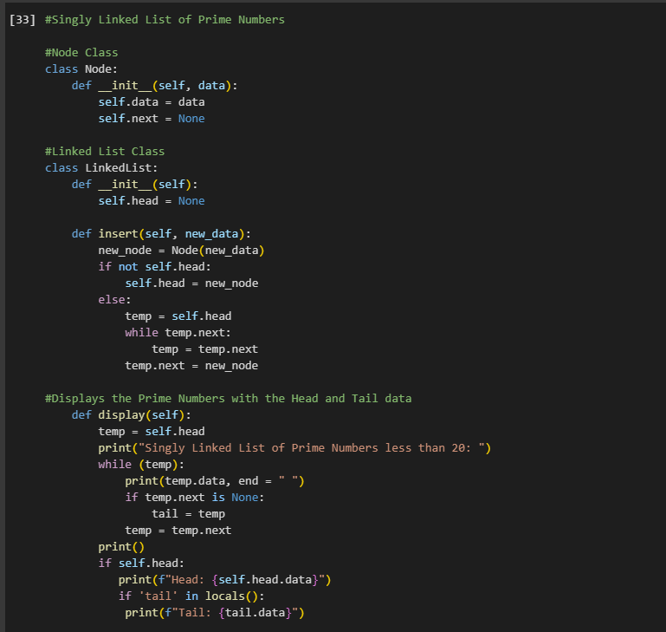

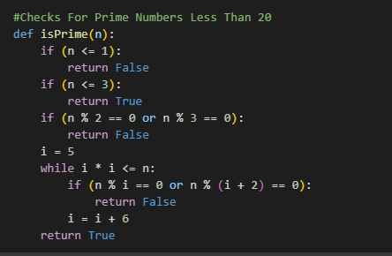

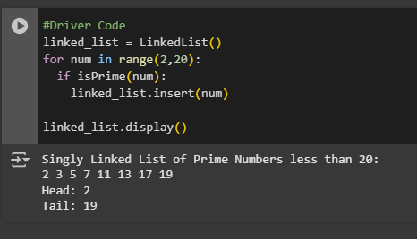

Figure 1 Screenshot of program

This Python program utilizes the range() function to iterate through integers from 2 to 19, identifying and storing prime numbers in a singly linked list. It then displays all the prime numbers found, along with the head and tail of the list.

Conclusion

Singly linked lists are great for managing simpler systems with fewer data,especially those in sequential order. They also offer non-contiguous memory allocation, making them suitable for systems with fragmented memory. Lastly, singly linked lists can grow or shrink dynamically,especially those with unpredictable data structures.

**References**

[1] Co Arthur O.. “University of Caloocan City Computer Engineering Department Honor Code,” UCC-CpE Departmental Policies, 2020.

[2] “W3Schools.com.” <https://www.w3schools.com/python/ref_func_range.asp> (Accessed August 23,2025)

[3]GeeksforGeeks, “Singly linked list in Python,” *GeeksforGeeks*, Jul. 23, 2025. <https://www.geeksforgeeks.org/python/singly-linked-list-in-python/> (Accessed August 23,2025)

[4] GeeksforGeeks, “Singly linked list in Python,” *GeeksforGeeks*, Jul. 23, 2025. <https://www.geeksforgeeks.org/python/singly-linked-list-in-python/> (Accessed August 23,2025)